Written by: Daniel Chadwick  Title: Mech. Systems Engineer  Date: Dec 5, 2016 | Reviewed by: Joshua Stewart  Title: Mech. Engineering Manger  Date: Dec 5, 2016 |  | Approved By: Paul Boykin  Title: Configuration and Change Management  Date: April 3, 2017

Purpose
Define part marking requirements for all purchased fabricated parts, fabricated assemblies, or molded parts.

Scope
This document applies to all fabricated production components and assemblies. These requirements define processes used by Proterra’s Suppliers to identify purchased components and assemblies.

Definitions
Part marking is used for identification of source, part number, revision level, and date of manufacture for purchased fabrications parts and assemblies. Part marking will better identify service part requirements, help with containment activities, and inventory control.

Related Documents
Proterra Supplier Quality Manual

Responsibilities
Part marking will be the responsibility of the part/assembly source Supplier. Part marking location specification is the responsibility of Proterra Engineering.

Procedure

Part marking and identification
Part marking and identification plates, tags, or labels used shall be as permanent as the normal life expectancy of the item and be capable of withstanding the environmental tests and cleaning procedures specified for the item to which it is affixed. Legibility shall be as required for ready human or machine readability as applicable. Information contained on identification plates shall be of a color that is in contrast to the color of the surface of the plate or part. Identification tag marking, when used, shall be permanent to the extent required for utilization of the item. Part marking shall be in block letters not created with permanent marking pen. All ink stamped part markings are to be covered by clear lacquer.

Part marking example
Part marking shall contain:
1. The Suppliers’ Vendor Identification Number (as assigned by Proterra Inc)
2. Proterra part number and revision level
3. Date of Manufacture
4. Serial Number if required

Example:

VEND 000000
PN 0100000 Rev. A
06042013
SN 1234567 (if required)

Part marking size requirements
 | Character Height  (Centimeters) | Character Height  (Inches) | Character Height  (Points)
Recommended | 0.2 cm | 0.08 in | 5.76 pts
Minimum | 0.125 cm | 0.05 in | 3.6 pts

Part marking location on parts and assemblies
The location of part marking may be shown on the Proterra engineering drawing or as defined by Proterra Engineering. Part marking tags shall not be applied to class “A” surfaces.

6.5 Part marking for small parts
Parts that are too small to accommodate direct part marking may be “bagged and tagged”. That is, the small part should be placed in a zip lock bag large enough to affix a standard size printed label with the information shown in section 6.2.

Part Serialization definition and expectations
Part Serial number is an identifying number assigned sequentially by the manufacturer.

6.7 Part serialization identification
Parts serialization will be specified by the Proterra engineering drawing.

6.8 Bus Body Marking
Bus body marking does not need to follow section 6.2, but rather will be marked as according to the directions outlined in this section (section 6.8). All bus bodies should be marked with a VIN on the horizontal surface underneath the headlight pass thru on the curbside of the vehicle (Figure 1). This VIN should be oriented to be so that left to right is curbside to streetside and top to bottom is fore to aft.

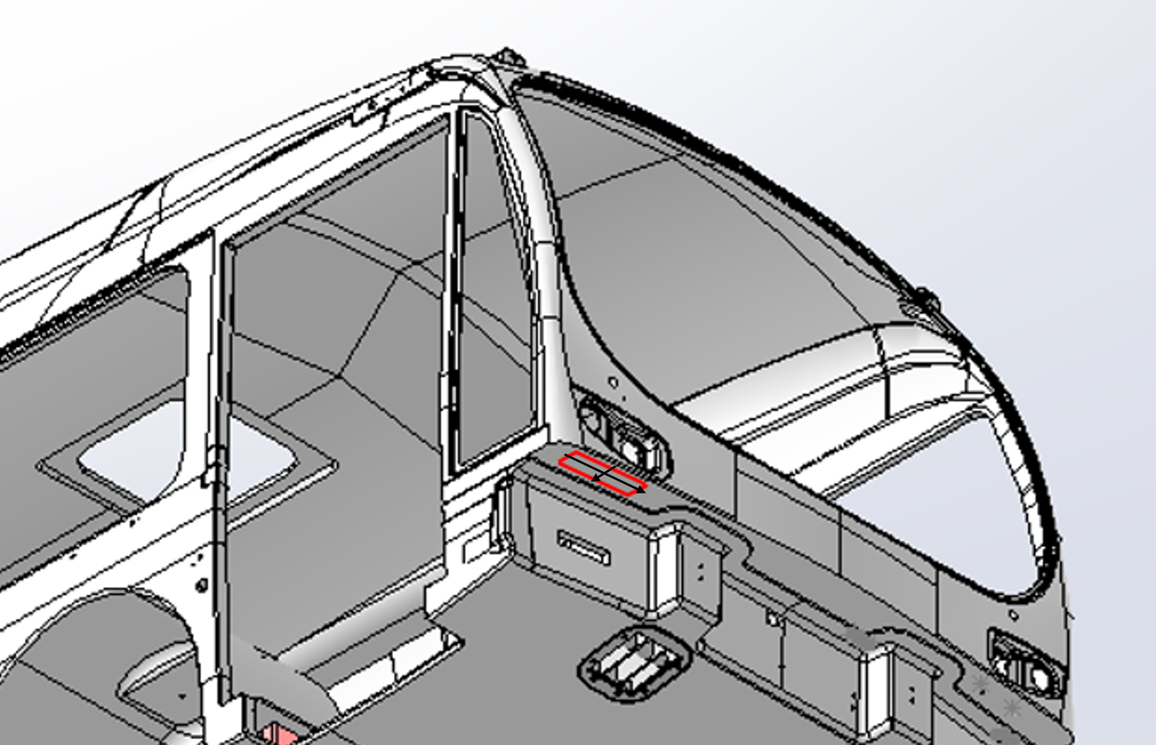
Figure 1: Location of VIN Marking

Body marking will follow the following format:

Manufacturer - Model Number - Mold # - Bus body #

Where the Manufacturer is a three character, marking corresponding to the manufacturer, Model Number will be either V2 for 40’ bus or V3 for 35’ bus, Mold # is which mold was used, and Bus Body # will be a three-digit number indicating the bus is the n^{th} bus produced by the manufacturer (of that particular model). For example, a 35’ bus produced by MFG from Mold 1 that is the 3rd 35’ bus to produced would be:

MFG-V3-01-003

Revision History

Date | Rev. | DCR # | Approver | Description of Change
07/23/2013 | A |  |  | Initial release
12/05/2016 | B |  |  | Add body marking standard

